Name | Carla S.
Photo | 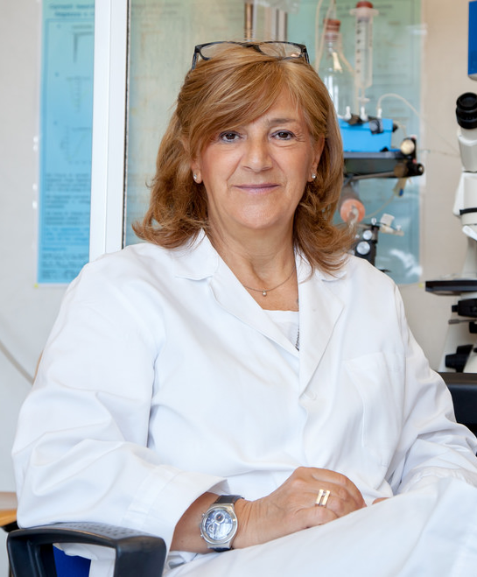
Age | 52
Nationality | Romanian
Country of Birth | Romania
Grew up in | Romania
Residence | Frankfurt am main, Hessen, Germany
Profession | Medical Doctor at University Hospital, Frankfurt
Backstory | Carla is an A&E doctor working in the german town of Frankfurt. She qualified in Romania and Germany. She speaks Romanian, German, English and Italian.  Over 20% of Frankfurt’s population are foreign-born. Circa 190K foreigners visit the city every month. As a result Carla sees often patient whose medical record are completely or partially located abroad.
Role | Doctor
Story | Carla is on shift at the A&E when Maria comes in.

